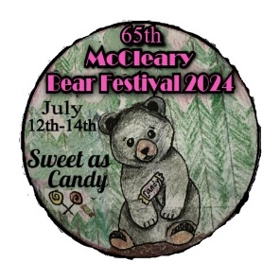
65th McCleary Second Growth and Bear Festival
Slow Pitch Softball Tournament Entry Form
July 12-14, 2024

Name of Team: ________________________________ Number of Players on Team: ___________
Mailing Address: _______________________________________________________________________
City: ___________________ State: _______ Zip: _________
Email: ___________________________________________________

General
- The entry fee is $300.00 per team. There are NO REGISTRATION REFUNDS.
- First 12 teams that pay in FULL by June 1st will be entered.
- Games will be played at Beerbower Park, located in McCleary, WA.
- This will be a 12-team, double elimination tournament.
- This is a wooden bat tournament. BYOB (Bring your own bats)

Please make check payable to: McCleary Bear Festival (in the memo space write Softball)
Mail completed entry for & check to:
McCleary Bear Festival
Attn: Softball Committee
PO Box 408
McCleary, WA 98557
Questions? Text or call Brian Atchison 360.561.2356 or email brian.atchison10@gmail.com

This is a non-sanctioned tournament with the following rules:
- USSSA rules apply.
- Only wooden bats allowed during play.
- Courtesy runners are allowed.
- Progressive home run rule applies: No team can be more than two (2) home runs ahead.
If a home run is hit with more than two (2) home runs ahead, it counts as an out.
- Accelerated count: 1-ball, 1-strike.
- Ten-run rule applies.
- Every Player/Umpire MUST sign an insurance waiver form before being allowed to play.
- Maximum number of pick-up players per team is three (3).
- A pick-up player may be used only if the team’s roster is less than 10-players.

Prizes will be awarded for the First, Second, and Third Place Teams. The First Place Team will also receive awards as follows:
- MVP Defensive Player
- MVP Offensive Player

The tentative scheduled games will be as follows: Friday night: three (3) games, with the 1st game (Guns & Hoses) starting at 6:30pm.

P.O. Box 408 McCleary, WA 98557 mcclearybearfestival.org • bearfestival@gmail.com

